Printed Resources
Use V-Library found on your toolbar or in the Cyberlibrary via Myclasses or Mydesktop
- Search via subject: “Shakespeare”(822.33B ), Romeo and Juliet, Elizabethan England (942.05),
- Search via keyword: “Shakespeare”, Romeo and Juliet (822.33 U3) Everyday life (942.05)
On-line Resources
1.EBSCO
- Online journal articles, which are authentic and reliable.
- Go to Cyberlibrary. Scroll down left hand side until you see: the EBSCO icon.
  - Click on History Reference Centre with Interface
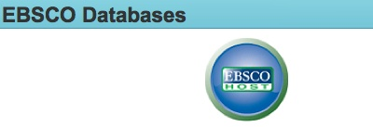
  - Search via key words: e.g. “Everyday life, renaissance”
- Back in EBSCO databases, Choose Literary Reference Centre 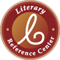
  - Search via key words “Renaissance, Everyday life Elizabethan England”.
2. Encyclopaedia Britannica
- Excellent for definitions and summaries of issues

Go to Cyberlibrary on “mydesktop”. Scroll down left hand side until you see: “Encyclopaedia Britannica - All levels”
- Use keywords of your topic to search (e.g. Elizabethan England everyday life, Shakespeare)
- Choose appropriate school level
- Click on title to get full paragraphs
- Use Harvard citation at bottom of page for bibliography
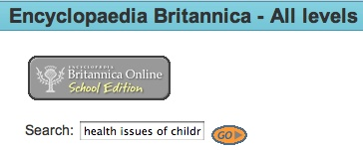
- Remember to click on “Additional Content” for further information
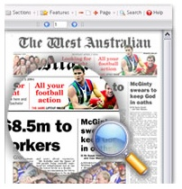
3. West Australian Digital Archive –
- On ‘mydesktop’, scroll down until you see ‘Iona Cyberlibrary’. Click on ‘The West Australian Digital Archive icon. Click on ‘Class Access’. Search with “” around search words.
E.g. “Shakespeare and England”
5. Websites:
- Choose websites that are authoritative, reliable, current and unbiased.
- Start with search terms such as “Elizabethan England”
“Paintings for R+J”
“Elizabethan Names"
"Faire Names for English Folk"
“Shakespeare’s Life and Times”
“Mr. William Shakespeare”
“Words coined by Shakespeare"
“Shakespeare’s Globe”
“The Globe”
“Shakespeare’s Dentist”
“Elizabeth I (1533-1603)”
- Hyperlinks to good websites:
“ RoadatIona”
“Romeo and Juliet”
“Elizabethan England”
“Plague”
“The Elizabethan Costuming Page”
“Crime and Punishment in Elizabethan England”
“Elizabethan England”
“Elizabethan England”
“Medicine”

- Google Scholar
- Found in the ‘More’, ‘even more’ Tab at the top of the Google search page
- Information found here is far more authentic and academic than found on usual Google

